**PSG COLLEGE OF TECHNOLOGY, COIMBATORE - 641 004**

**DEPARTMENT OF APPLIED MATHEMATICS AND COMPUTATIONAL SCIENCES**

**Practice sheet – MongoDB**

**Practice Sheet : 1 Topic coverage: installation of MongoDB and CRUD operations**

**Problem Sheet -1 - Installation of MongoDB**

**Installation**

<https://docs.mongodb.com/compass/master/install/>

<https://www.mongodb.com/cloud>

**Database :**

use "db"

**Create a collection**

Use db.createCollection to create a collection

db.createCollection('mammals')

db.mammals.insert({name: "Polar Bear"})

db.mammals.insert({name: "Star Nosed Mole"})

## **Create Operation**

[db.collection.insertOne()](https://docs.mongodb.com/manual/reference/method/db.collection.insertOne/#db.collection.insertOne)

[db.collection.insertMany()](https://docs.mongodb.com/manual/reference/method/db.collection.insertMany/#db.collection.insertMany)

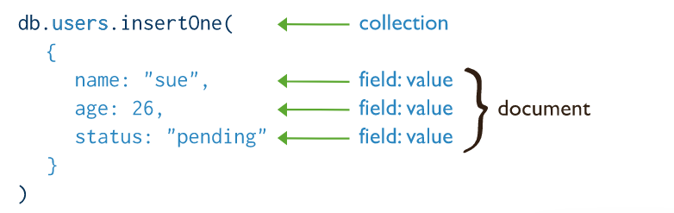

Documents are JSON objects that live inside a collection. They can be any valid JSON format, with the caveat that they can't contain functions. The size limit for a document is 16Mb which is more than ample for most use cases.

## **Read Operations**

[db.collection.find()](https://docs.mongodb.com/manual/reference/method/db.collection.find/#db.collection.find)

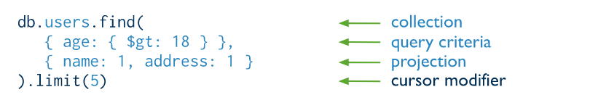

Finding a document

db.mammals.find()

**Excercise-2**

**MongoDB: Inserting a document into a collection(Create)**

**The command db.collection.insert()**

db.student.insert({

regNo: "3014",

name: "Test Student",

course: {

courseName: "MCA",

duration: "3 Years"

},

address: {

city: "Bangalore",

state: "KA",

country: "India"

}

})

## **Update Operations**

* [db.collection.updateOne()](https://docs.mongodb.com/manual/reference/method/db.collection.updateOne/#db.collection.updateOne)
* [db.collection.updateMany()](https://docs.mongodb.com/manual/reference/method/db.collection.updateMany/#db.collection.updateMany)
* [db.collection.replaceOne()](https://docs.mongodb.com/manual/reference/method/db.collection.replaceOne/#db.collection.replaceOne)

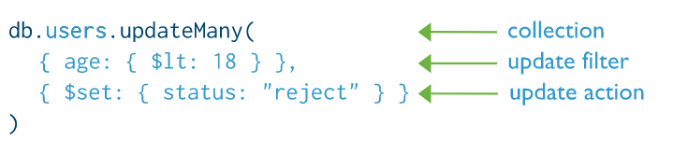

## **Delete Operations**

* [db.collection.deleteOne()](https://docs.mongodb.com/manual/reference/method/db.collection.deleteOne/#db.collection.deleteOne)
* [db.collection.deleteMany()](https://docs.mongodb.com/manual/reference/method/db.collection.deleteMany/#db.collection.deleteMany)

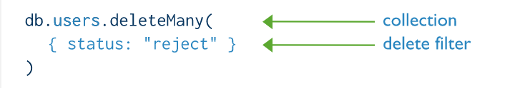

Practice Excercises:

Create movies documents and insert the following documents into a movies collection.

title : Fight Club

writer : Chuck Palahniuk

year : 1999

actors : [

Brad Pitt

Edward Norton

]

title : Pulp Fiction

writer : Quentin Tarantino

year : 1994

actors : [

John Travolta

Uma Thurman

]

## Query Documents

1. Perform CRUD operations in MongDB
2. get all documents
3. get all documents with writer set to "Quentin Tarantino"
4. get all documents where actors include "Brad Pitt"
5. get all documents with franchise set to "The Hobbit"
6. get all movies released in the 90s
7. get all movies released before the year 2000 or after 2010

**Learning Link:**

**https://docs.mongodb.com/manual/crud/**

[https://docs.mongodb.com/manual/core/databases-and-collections/#collections](https://docs.mongodb.com/manual/core/databases-and-collections/)

<https://docs.mongodb.com/manual/tutorial/insert-documents/>